UNIT II

CHARACTERISTICS OF OPAMP

PART-A

1. What is input offset voltage?(April/May-15),(Nov/Dec-19)

The voltage required to be applied between the input terminals of an op-amp to nullify the output is called input offset voltage. This voltage could be positive or negative. For 741C, the maximum value is 6mV.

2. What is input off set current? (April/May-15),(Nov/Dec-19)

The algebraic difference between the currents entering in to (-ve) input (I_{B}⁻) and (+ve) input (I_{B}⁺) is referred to as input off set current. Its maximum value is 200 nA for 741C.
I_{OS} = I_{B}⁺ - I_{B} ⁻

3. Define CMRR. (April/May-15),(Nov/Dec-19)

The ability of a differential amplifier to reject common mode signal is expressed by the ratio of differential gain to the common mode gain which is called its common mode rejection ration CMRR. The ideal value of the CMRR is infinite

It is defined as the ratio of the differential voltage gain (A_{d}) to common mode gain (A_{c})

CMRR = ρ = │A_{d}/A_{c}│

Ideal value of A_{c} is zero; hence ideal value of CMRR is infinite

CMRR in dB = 20 log │A_{d}/A_{c}│ Db

- What is an ideal characteristics op-amp?(May/Jun-15,16,18),(Nov-19)

An op-amp is said to be ideal, if it has the following characteristics
- Open loop voltage gain, A_{OL} = ∞

- Input resistance, R_{I} = ∞

- Output impedance, R₀ = ∞

- Band width, B.W = ∞

Zero offset, V₀ = 0, where V₁=V₂=0

5. What is thermal drift?(Nov/Dec-14)

In an op-amp the bias current, offset current and off set voltage changes with change in temperature. Offset current drift is measured in nA/ ⁰C and offset voltage drift is measured in mV/ ⁰C.

- State the causes for slew rate in an operational amplifier?(May/June-16)

  - Slew rate can be defined as the maximum rate of change of output voltage of op-amp with respect to time
  - The rate at which the internal or external capacitance of op-amp charges causes slew rate Also slew rate is caused by current limiting and saturation of internal stages of op-amp where a high frequency, large – amplitude signal is

applied. dV_{C}/dt = I/C

Where V_{C} – voltage across the capacitor

- List any four non ideal dc characteristics of op-amp.(May/June-12)

  - Input bias current

  - Input off set current

  - Input offset voltage

  - Thermal drift
8. What is the input impedance of non inverting amplifier? (May/June-13)
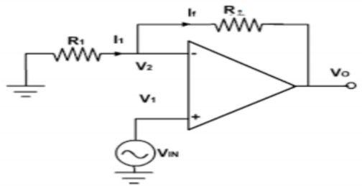

Vo/Vi = 1+(Rf/Ri)

- Draw the circuit diagram of integrator and give its output equation.
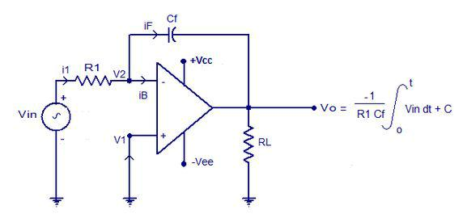
(May/Jun-16) (Nov/Dec-19)

- Define Voltage follower.(Apr/May 2018)

- When the Non-Inverting amplifier is designed for unity and it is called a voltage follower, because the output voltage is equal to and in-phase with the input or in volt follower the output follows the input.

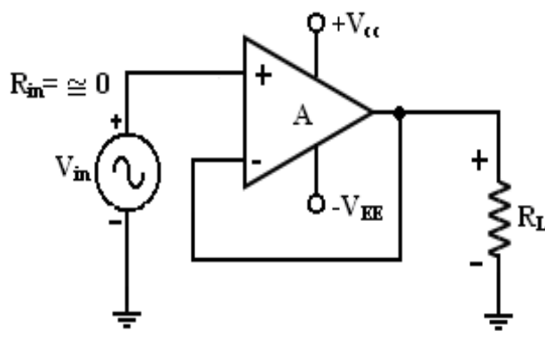
- Mention some of the linear applications of op – amps.(Nov/Dec 16)
Adder, subtract or, voltage –to- current converter, current –to- voltage converters, Instrumentation amplifier, analog computation, power amplifier, etc are some of the Linear op-amp circuits.

12. What is input bias current?(May 2016)

The average of the currents entering the negative input (I_{B}⁻) and positive input (I_{B}⁺) of an op-amp is called input bias current(I_{B}), Its value is 500nA for 741C.

The equation is

I_{B} = I_{B}⁺ - I_{B}⁻ / 2

- What is OPAMP?

An operational amplifier is a direct coupled high gain amplifier consisting of one more differential amplifiers , followed by a level translator and an output stage. It is a versatile device that can be used to amplify ac as well as dc input signals & designed
for computing mathematical functions such as addition, subtraction , multiplication, integration & differentiation.
14. Define slew Rate. (Apr/May -18)

- The slew rate is defined as the maximum rate of change of output voltage caused by a step input voltage. An ideal slew rate is infinite which means that op-amp’s output voltage should change instantaneously in response to input step voltage.
- Slew rate = 2πfV_{m}/10⁶.μv/sec

15. What you mean by balanced and unbalanced output?

The differential amplifier uses two transistors in CE configuration. If the output is taken across the two collectors, it is called balanced output or double ended output. If the output is taken across one of the collectors with respect to ground it is called unbalanced output or single ended output

16.Draw the circuit diagram of emitter coupled differential amplifier?(Apr/May-17)
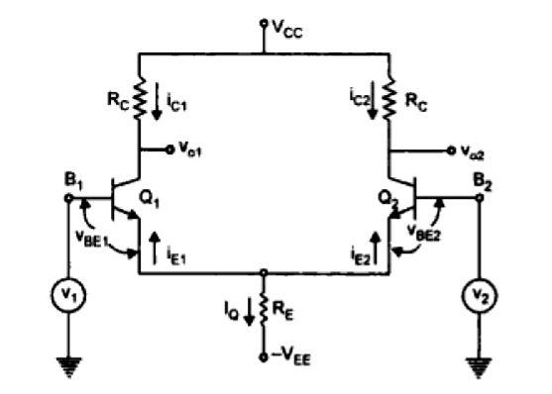

17. Give the Drawback of IC741?(Nov/Dec 2017)
- Most OP-AMP are Designed to for lower power operation.
- For high output desire then the OP-AMP specifically designed for that purpose must be seen.
- Most commercial OP-AMP shuts off when the load resistance is below the specific level.

18.Why is IC741 op-amp not used for high frequency applications?(May/june-16)

Op-amp IC741 has very low slew rate (0.5V/μS) and therefore can not be used

for high frequency applications.

19.Explain the working of Integrator (Nov/Dec-2016)
A circuit in which the output voltage wave is the integral of the input voltage waveform is the Integrator or Integration Amplifier.

20. What are the basic differential amplifier configurations?
The four basic differential amplifier configurations are
  - Dual input and balanced output differential amplifier

  - Dual input and unbalanced output differential amplifier

  - Single input and balanced output differential amplifier

  - Single input and unbalanced output differential amplifier.

21.The output of a certain op-amp circuit changes by 20V in 4μS. What is the

slew rate?

Slew rate = dV₀/dt = 20V/4μS Slew rate = 5V/μs

22. Define RRR.

The ability of the circuit to reject input ripples are present at the output due to input is given by the factor ripple rejection ratio (RRR)

RRR = 20 log₁₀ [V_{ri} / V_{ro}]

Where

V_{ri –} input ripple magnitude

V_{ro} – output ripple magnitude

Higher the value of RRR, better in the performance of the circuit.

23. Define differential gain or difference mode gain.

Differential gain is the gain with which differential amplifier amplifies the difference between two input signals V₁ and V₂. It is denoted by A_{d}

A_{d} = V₀/V_{d}

Where V₀ = output voltage

V_{d =} Differential Voltage (V₁- V₂)
24. Define common mode gain.

The gain with which differential amplifier amplifies the common mode input signal to produce the output is called common mode gain, denoted by A_{C}

A_{C} = V₀/V_{C}

Where

V₀ = output voltage

V_{C} =common mode input voltage (V₁ + V₂ / 2)

25. What are swamping resistors?

The difference mode gain of the differential amplifier depends on h-parameters which changes due to factors like temperature and the effect the voltage gain to change in h-parameter values , the external resistance R_{E}’ are connected in series with each emitter. Such resistances are called swamping resistors.

PART-B

- Explain in detail about the method of frequency compensation techniques applied to operational amplifiers. (May/June-16)(April/May-15)(Nov/Dec-19) (April/May-17)

When lower closed loop gain and larger bandwidth is required for a system, suitable compensation techniques are used. The two methods are

- External compensation

- dominant pole compensation

- pole-zero(lag) compensation

- Internal compensation

EXTERNAL COMPENSATION:

When op-amps are to be used for lower closed loop gain, they are compensated with externally connected compensation components the compensating network alerts the open loop gain so that roll-off rate is -20dB/decade over a wide range of frequency. The common methods are
DOMINANT POLE COMPENSATION:
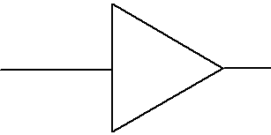

V |  | V_{o}' | R
i | A |  | V_{o}
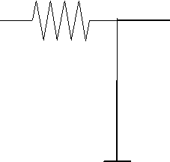
C

Consider uncompensated transfer function, A of an op-amp in open loop condition is given by the equation.

A = | A_{OL} .ω₁ .ω₂ .ω₃
A = | (S + ω₁ )(S + ω₂ )(S + ω₃ )

Now we introduce dominant pole by RC network in series with op-amp as shown in figure. Now compensated transfer function A becomes
A = |  |  |  | V₀ |  |  | = |  |  |  |  | − jX _{C} |  |  |  |  |  | = |  |  |  |  |  |  |  |  | 1
1 |  |  | V_{o} |  |  | ' |  |  |  |  | R − jX _{C} |  |  |  |  |  |  |  |  |  |  |  |  |  |  | ⎛ |  | R | ⎞
 |  |  |  |  |  |  |  |  |  |  |  |  |  |  |  |  |  |  |  |  |  | 1 + |  |  |  | ⎜ |  |  | ⎟
 |  |  |  |  |  |  |  |  |  |  |  |  |  |  |  |  |  |  |  |  |  |  |  |  |  | ⎜ | − |  | ⎟
 |  |  |  |  |  |  |  |  |  |  |  |  |  |  |  |  |  |  |  |  |  |  |  |  |  | ⎝ | − | ^{jX} C ⎠
A₁ | = |  | 1 |  |  |  |  |  |  | = |  |  | 1
A₁ | = |  |  |  |  | jR |  |  |  |  |  |  | + j 2πfRC
 |  | 1 + |  |  |  |  |  |  |  | 1
 |  |  |  |  | ^{X} C
but ^{f} d | = | 1
but ^{f} d | = | 2πRC
 |  |  |  |  |  |  | ∴ A₁ = |  |  |  |  |  |  |  |  | 1
 |  |  |  |  |  |  |  |  |  |  |  |  |  |  |  |  |  |  |  | jf
 |  |  |  |  |  |  |  |  |  |  |  |  | 1 + |  |  |  |  |  |  |  |  |  |  | --------------------- (1)
 |  |  |  |  |  |  |  |  |  |  |  |  |  |  |  |  |  |  |  | f _{d}

 |  |  |  |  |  |  | ^{A}OL
 | ⎛ |  |  | f | ⎞⎛ |  |  |  | f | ⎞⎛ |  |  | f | ⎞
 | ⎜ |  | + j |  | ⎟⎜ |  |  |  |  | ⎟⎜ |  |  |  | ⎟
A = | ⎜ | 1 | + j |  | ⎟⎜ | 1 | + j |  |  | ⎟⎜ | 1 | + j |  | ⎟ | ------------------ (3)
A = | ⎜ | 1 | + j | f₁ | ⎟⎜ | 1 |  |  | f ₂ | ⎟⎜ | 1 | + j | f ₃ | ⎟ | ------------------ (3)
 | ⎝ |  |  | f₁ | ⎠⎝ |  |  |  | f ₂ | ⎠⎝ |  |  | f ₃ | ⎠

 |  |  |  |  |  | ^{A}OL
⎛ |  |  | f |  | ⎞⎛ | f | ⎞⎛ | f |  | ⎞⎛ | f |  | ⎞
 | ⎜ |  |  |  | ⎟⎜ | f | ⎟⎜ |  |  | ⎟⎜ |  |  | ⎟
A’ =
A’ = | ⎜1+ j |  | f |  | ⎟⎜1+ j | f | ⎟⎜1+ j | f |  | ⎟⎜1+ j | f |  | ⎟ |  | -------- (3)
⎝ |  |  |  | d ⎠⎝ |  | 1 | ⎠⎝ |  | 2 | ⎠⎝ |  | 3 | ⎠

Where f_{d} < f₁ < f₂ < f₃,

The frequency Vs Gain plot is given as,

A_{O L} (dB)
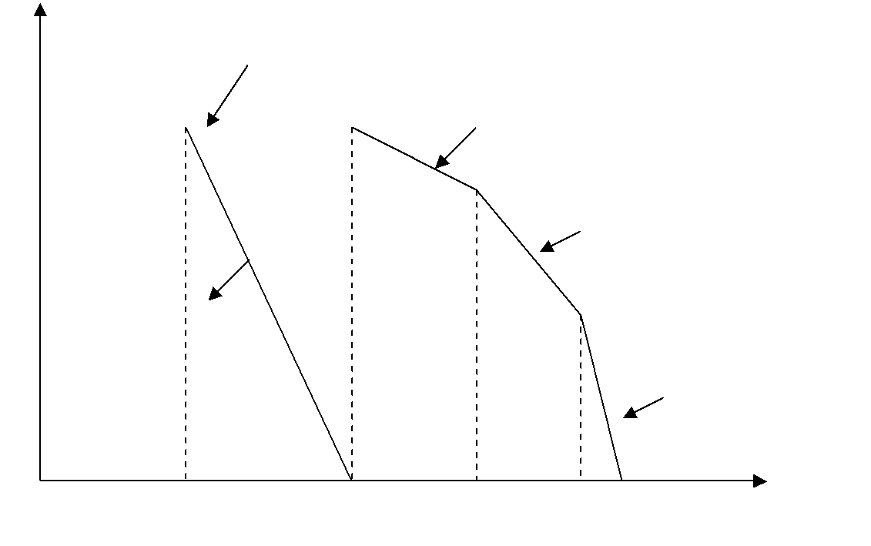

Uncompensate

 |  | -20dB/decade
 |  |  | -40dB/decade
Dominant
Pole |  |  | -60dB/decade
Compensatio

0 f_{d} f1 f2 f₃ f (on log scale)

The values of R and C are selected in such a way that open loop gain drops to 0dB with a slope of -20dB/decade, at a frequency (f₁) where the poles of uncompensated system contributes very small phase shift. Generally, f_{d} is selected so that magnitude plot of A’ passes through 0dB at pole f₁ of A. (i.e, ω _{gc} = f₁)
ADVANTAGES:

- Since noise frequency components are outside smaller bandwidth, noise immunity of the system is improved.

- Adjusting the value of f_{d}, adequate phase margin and the stability of the system is assured.

LIMITATIONS:

- It reduces the bandwidth from f₁ to f_{d} , thus bandwidth is drastically reduced

- The poles should be real.
POLE ZERO (LAG) COMPENSATION:

 |  |  |  | Compensating Network
 |  |  |  | Z₁
 |  |  |  | }
^{V}i |  | A | V_{o}' | ^{R}1 |  |  |  |  |  |  |  | ^{V}o
 |  | A |  |  |  |  |  |  |  |  | _{C}^{R2}}Z₂
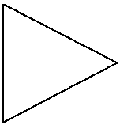
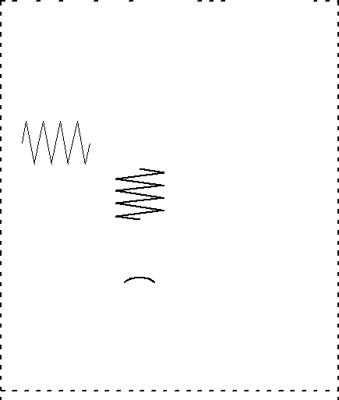

Consider the transfer function of a compensated Op-Amp with three break frequencies,

 |  |  |  |  |  |  | AoL
A = | ⎛ |  |  | F | ⎞⎛ |  |  | f | ⎞⎛ |  |  | f | ⎞ | ------------------ (4)
A = | ⎜ | 1 | + j | F | ⎟⎜ | 1 | + j | f | ⎟⎜ | 1 | + j | f | ⎟ | ------------------ (4)
 | ⎜ | 1 | + j |  | ⎟⎜ | 1 | + j |  | ⎟⎜ | 1 | + j |  | ⎟
 | ⎜ | 1 | + j | f₁ | ⎟⎜ | 1 | + j | ^{f} 2 | ⎟⎜ | 1 | + j |  | ⎟
 | ⎝ |  |  | f₁ | ⎠⎝ |  |  | ^{f} 2 | ⎠⎝ |  |  | ^{f}3 ⎠

transfer function A is modified by adding a pole and a zero with help of a compensating network. The zero is added at high frequency, while pole is added at low frequency. The transfer function of compensating n/w is say A_{1,}
 | V _{o} | = | Z ₂
 |  | = | Z ₁ + Z ₂
A1 = V _{o} ' |  |  | Z ₁ + Z ₂

Where, Z₁=R₁, Z₂ = R₂ – j X_{c2}

R ₂ - j X _{c2}

A1 = R ₁ + R ₂ - j X _{c2}

Dividing the above equation by jX_{c2}, we get
 |  |  |  |  |  |  | R ₂ |  |  | +1 |  |  |  |  |  |  |  | 1+ j |  |  |  |  |  |  | R ₂
 |  |  |  |  | - j X_{c2} |  |  |  |  |  |  |  |  |  |  | = |  |  |  |  |  |  |  |  | ^{X}c2
A₁ = |  |  | (R₁ + R ₂ ) |  |  |  |  |  |  |  |  |  |  |  |  |  |  |  |  |  |  |  | (R₁ + R ₂ )
 |  |  |  |  |  |  |  |  |  |  | +1 1+ j
 |  |  |  |  |  |  |  | 1 + jR ₂ ( 2πfC ₂ ) |  |  |  |  |  |  |  |  |  |  |  |  |  |  |  |  |  |  |  |  | ^{Q} X_{c2} = 2π.f.C₂
 |  |  |  |  | ⁼ 1 + j (R ₁ + R ₂ )( 2πfC ₂ )
 | ⎛ |  |  |  | 1 |  |  | + |  |  | j |  |  |  |  |  | f |  |  |  |  | ⎞
 | ⎜ |  |  |  |  |  |  | + |  |  |  |  |  |  |  |  |  |  |  |  |  | ⎟
 |  |  |  |  |  |  |  | + |  |  |  |  |  |  |  | f
 | ⎜ |  |  |  |  |  |  |  |  |  |  |  |  |  |  |  |  | 1 |  |  |  | ⎟
A₂ = | ⎜ |  |  |  | 1 |  |  | + |  |  | j |  |  |  |  |  | f |  |  |  |  | ⎟ |  |  |  |  | ------------------(5)
A₂ = | ⎜ |  |  |  |  |  |  | + |  |  | j |  |  |  |  |  |  |  |  |  |  | ⎟
A₂ = |  |  |  |  |  |  |  | + |  |  | j |  |  |  |  | f
 | ⎝ |  |  |  |  |  |  |  |  |  |  |  |  |  |  |  |  | o |  |  |  | ⎠
 |  |  |  |  |  |  |  | 1 |  |  |  |  |  |  |  |  |  |  |  |  |  |  |  |  |  |  |  | 1
 |  |  |  | 2 π R ₂ |  |  |  |  |  | C ₂
where, f₁ = |  |  |  |  |  |  |  |  |  |  |  |  |  |  |  |  |  | , f_{o} = |  |  |  |  |  | 2 π ( R ₁ |  |  |  |  | + R ₂ ) C ₂

The values of R₁,R₂ and C₂ are selected so that break frequency for zero matches with first corner frequency,f₁.While pole of the compensating network at f₀ is selected in such a way that the compensated transfer function A’ passes through 0 dB at second corner frequency f₂.Resultant loop gain is,

A_{O L} (dB)

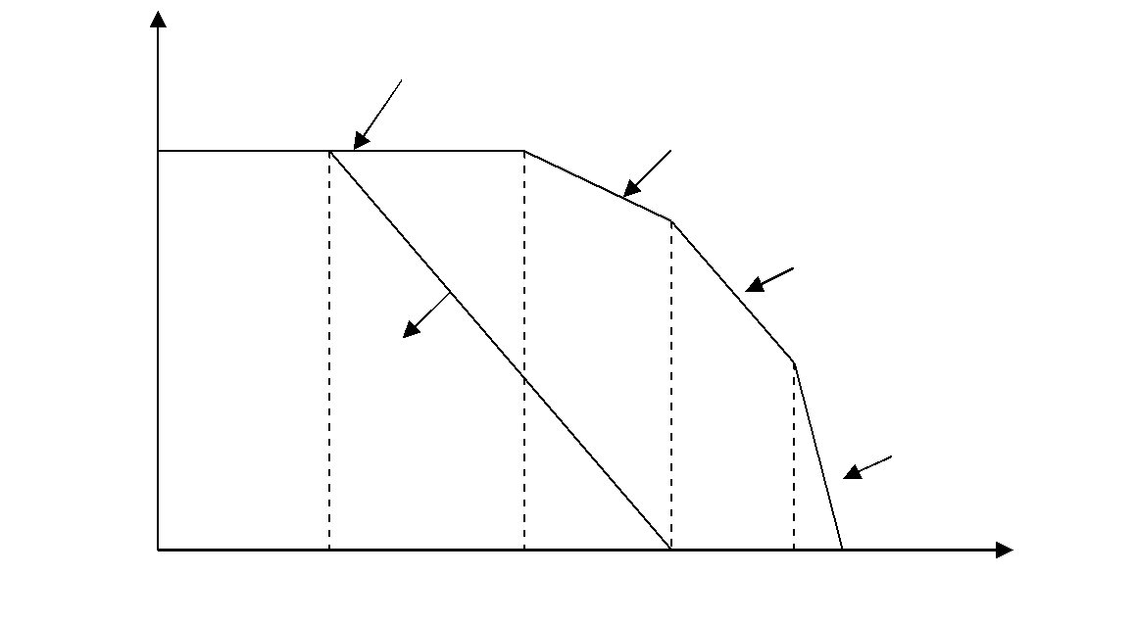

-

0 f₀ f1 f2 f₃ f (on log

 | A’ = A.A₁ |  |  | ------------------ (6)
Using (1), (2) and (3), we get,
⎛ |  |  | f | ⎞
⎜ |  | + j | f | ⎟
 |  | + j | f | ⎟
 | ^{A}OL ⎜¹ | + j | f | ⎟
 | ⎝ |  | 1 | ⎠

 | ⎛ |  | f |  | ⎞⎛ |  | f | ⎞⎛ |  | f |  | ⎞⎛ |  | f |  | ⎞
A = | ⎛ |  |  |  | ⎞⎛ |  | f | ⎞⎛ |  |  |  | ⎞⎛ |  |  |  | ⎞ | ----------------- (B)
A = | ⎜ | + j |  |  | ⎟⎜ | + j | f | ⎟⎜ | + j |  |  | ⎟⎜ | + j |  |  | ⎟ | ----------------- (B)
 | ⎜¹ | + j |  |  | ⎟⎜¹ | + j |  | ⎟⎜¹ | + j |  |  | ⎟⎜¹ | + j |  |  | ⎟
 | ⎜¹ | + j | f | 0 | ⎟⎜¹ | + j | f | ⎟⎜¹ | + j | f | 2 | ⎟⎜¹ | + j | f | 3 | ⎟
 | ⎝ |  |  | 0 | ⎠⎝ |  | 1 | ⎠⎝ |  |  | 2 | ⎠⎝ |  |  | 3 | ⎠
Where f_{o} < f₁ < f₂ < f₃.

Now f_{o} is the first corner frequency and roll of rate is -20dB/decade. At f₁, there is pole-zero compensation roll-off rate maintains constant. The values of R₁, R₂, and C₂ are selected such that gain (A_{OL}) drops to zero at f₂ (i.e, ω _{gc} = f₂).

ADVANTAGE:

Comparing to dominant-pole compensation there is improvement in bandwidth equal to (f₂-f₁). This is the advantage of pole-zero compensation.

INTERNAL COMPENSATION:

In recent Op-amps, compensation is provided internally with a capacitance C₁ of 30pF that internally shunts off signal current and hence reducing the output signals at high frequencies. This causes A_{OL} to roll off at -20dB/decade as assures a stable circuit.
These Op-amps are called as internally compensated Op-Amps and the technique is called as Miller effect compensation.

A_{OL}(dB)
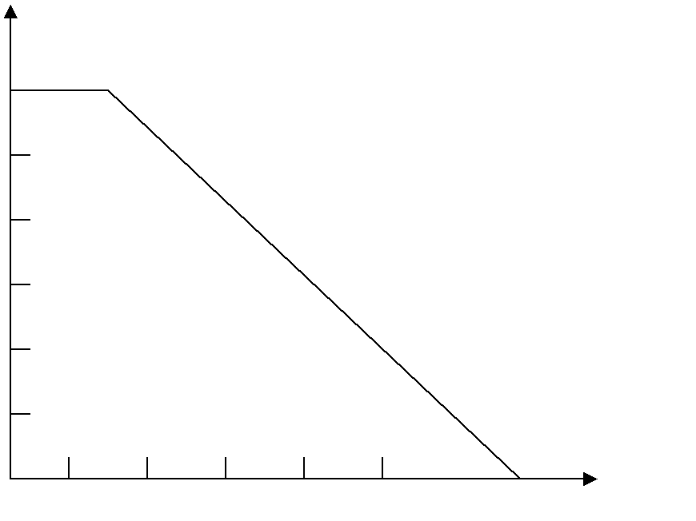

10

10

10

10

1

f
10 10 1k 10 100k

2.Define slew rate. Derive its equation. Write notes on method of improving slew rate. (April/May-19)(Nov/Dec15)
The slew rate is defined as maximum rate of change of output voltage with time. It is specified in V/μS. Thus
⎛ dV |  | 0 | ⎞
⎜ |  | 0 | ⎟
⎜ | dt |  | ⎟
Slew rate = S = ⎝ | dt |  | ⎠ MAX

CAUSES:

Slew rate is caused due to limited changing rate of compensating capacitor, current limiting and saturation of internal stages of op-amp, when a high frequency, large amplitude signal is applied. It is given by,
^{dV} C ₌ ^{I}

dt C

For large charging rate, capacitor should be small or charging amount should be large. Hence slew rate of op-amp is given by,
here, ^{I} ^{max} is the maximum internal capacitor charging current. The slew rate for non-inverting amplifier is worst. Higher the value of slew rate better is the performance of op-amp.
SLEW RATE EQUATION:

V_{S}=V_{O}
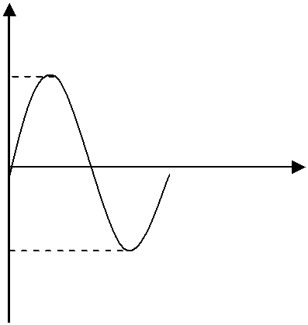

INPUT SIGNAL

Vm
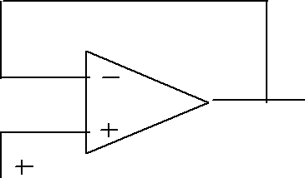

t
^{V}O

V_{S} 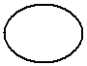 -Vm

Let input signal V_{S} is purely sinusoidal. Since the circuit is a voltage follower, the output is also purely sinusoidal. In such circuit output voltage follows input voltage.

V_{S} = V_{m} sinωt

V₀ = V_{m} sinωt

This is the required slew rate equation.

The maximum signal frequency, f_{m} is the maximum allowable frequency of input signal at which undistorted output can be obtained.

∴ f_{m} | = | S
∴ f_{m} | = | 2πV_{m} |  | ------------------ (B)

METHODS OF IMPROVING SLEW RATE:

C

v_{n} |  |  |  |  |  |  |  |  |  |  |  |  |  |  |  |  |  |  |  |  |  |  |  |  |  |  |  |  |  |  |  |  |  |  |  |  |  |  |  |  |  |  |  | V |  |  |  |  |  |  |  |  |  |  |  |  |  |  |  |  |  | V_{O}
 |  |  |  |  |  |  |  |  |  |  |  |  |  | ^{g}m1 |  |  |  |  |  |  |  |  |  |  |  |  |  |  |  |  |  |  |  |  |  |  | a |  |  |  |  |  |  |  |  |  |  |  |  |  | a
 | v_{p} |  |  |  |  |  |  |  |  |  |  |  |  |  |  |  |  |  |  |  |  |  |  |  |  |  |  |  |  |  |  |  |  |  |  |  |  |  |  |  |  |  |  |  | O2
 |  |  |  |  |  |  |  |  |  |  |  |  |  |  |  |  |  |  |  |  |  |  |  |  |  |  |  |  |  |  |  |  |  |  |  | 2 |  |  |  |  |  |  |  |  |  |  |  |  |  | 3
 |  |  |  |  |  |  |  |  |  |  |  |  |  |  |  |  |  |  |  |  |  |  |  |  |  |  |  |  |  |  |  |  |  |  |  |  | a >>1
 |  |  |  |  |  |  |  |  |  |  |  |  |  |  |  |  |  |  |  |  |  |  |  |  |  |  |  | ^{I}O1 |  |  |  |  |  |  |  |  |  |  |  |  |  |  |  |  |  |  |  |  |  |  | a₃=1
 |  |  |  |  |  |  |  |  |  |  |  |  |  |  |  |  |  |  |  |  |  |  |  |  |  |  |  |  |  |  |  |  |  |  |  | 2
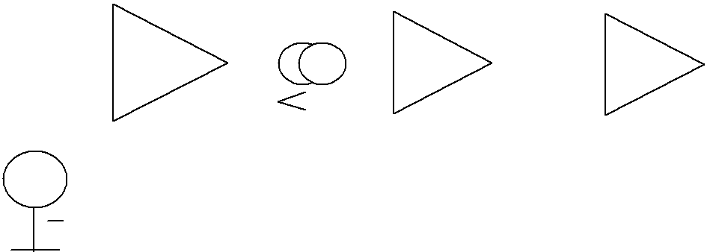

^{V}S

Consider the above op-amp model for analysis of the slew rate. The op-amp is used in voltage follower mode so V₀ = V_{i}. When input overdrives the input stage then I_{max} = I_{01(sat)} which are saturation of current levels of input stage. Under this condition the op-amp is operating under large signal conditions

 |  |  |  | C |  | d .v ₀₂
 |  |  |  | C |  |  | dt
I01 (sat) =
 |  | d . v ₀₂ |  |  |  |  |  |  | = |  |  | I | 01 ( sat )
 |  |  | dt |  |  |  |  |  | = |  |  |  | C
 | d.v |  | 02 | = | ⎛ |  | d .v |  | 02 | ⎞ |  |  | = S
 |  |  | 02 | = | ⎜ |  |  |  | 02 | ⎟ |  |  | = S
 |  |  |  | = |  |  | dt |  |  |  |  |  | = S
 |  | dt |  |  | ⎝ |  |  |  |  | ⎠max

Analyzing the op-amp model used we can write,

V₀₂ = drop across C = Z_{C}.I₀₁--------------------- | (2)

The input stage is the transconductance amplifier i.e, voltage input, and current output amplifier. Hence

Output current = g_{m} X (differential input)
∴ I₀₁ = g_{m} (V_{p}-V_{n})---------------------- | (3)

But V₀₂ ≈ V₀ , a₃ ≈ 1

∴ V₀₂ = V₀ = Z_{C} [g_{m1} (V_{p}-V_{n})]

1
∴ _{V0} ₌ _{jωC} ^{[g}m1 ^{(V}p ^{- V}n ^{)]}

From the above equation we discuss the methods of improving slew rate.

1.Increasing f_{t}:

Higher the gain bandwidth product, ft, higher is the slew rate. To increase f_{t}, the internal capacitor value must be reduced. Frequency compensation schemes like feed-forward compensation can be used to achieve higher f_{t} and thus higher slew rate.

2. Increasing I_{01 (sat)}:

It is very difficult to increase I_{01(sat)},since we cant control it externally by user. But without affecting g_{m} value we can increase I_{01(sat)} by providing alternate path for rapid

changing and discharging of C. this is possible by using additional input transistor pair which conducts when large amplifier input signal is applied.

3. Reducing g_{m}:

The gain of the differential input stage can be reduced by using suitable resistances in series with emitters of differential input transistors. This technique
is called emitter degeneration. Reducing input stage transconductance (g_{m}) by this method, slew rate can be improved.

3.Write notes on Differentiator. (Or) Explain the operation of differentiation amplifier with neat circuit diagram. (Nov/Dec -19)(April/May-19)

- Differentiator or Differentiation amplifier is a circuit which performs mathematical operation of differentiation. i.e., the output waveform is the derivative of the input waveform.

IDEAL DIFFERENTIATOR

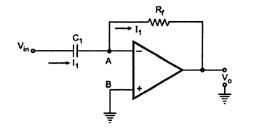

- The node A is at virtual ground i.e., V_{A}= 0
- The current through capacitor is 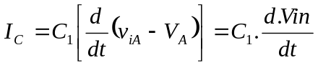 -------- (1)
The circuit i_{F} though R_{F} is given by

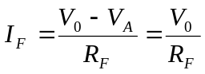 ------------ (2) since 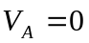
- At node A, by KCL (i.e) equations (1) + (2)
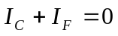
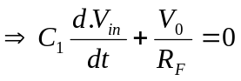
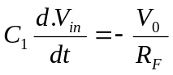
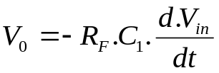
 --------------- (3)

- Thus the outputvoltage,V₀ is (-R_{F}C₁) times the derivative of input voltage V_{in}. The minus indicates phase shift of 180º between i/p signals.
- Writing equation (3) in frequency domain, we get

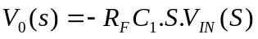
- Now gain ‘A’ of the differentiator is

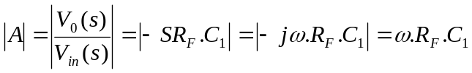 ( s = jω , ω = 2πf)
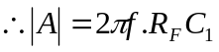
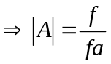-----------------------(4)
where
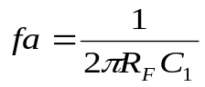
-------------------(5)

At f=fa, 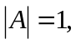 i.e 0 dB and gain increases at a rate of +20dB/decade.
DEMERITS:
- The i/p impedance (1/ωC₁) decreases with increase in frequency, thereby making the circuit sensitive to high frequency noise.
- Also, at high frequencies, the ckt, becomes unstable and enters into oscillation.
PRACTICAL DIFFERENTIATOR

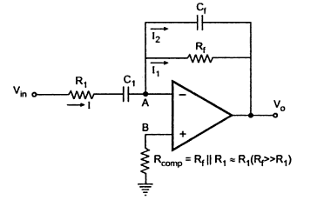

- Both stability and high frequency noise problems can be corrected by adding two components, R₁ & C_{F} as shown in above circuit. The transfer function of this circuit is
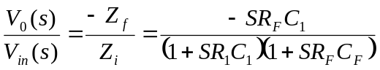
For R₁C₁ = R_{F}C_{F,}
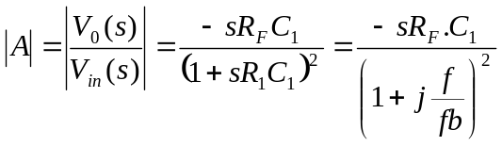
where
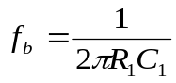

FREQUENCY RESPONSE:

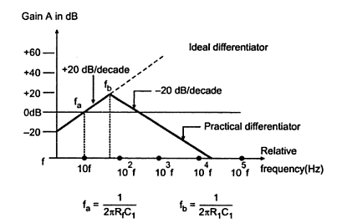
- f_{a} is the frequency at which gain is 0 dB. , f_{b} is the gain limiting frequency, f_{C} is the unity gain bandwidth of Op-Amp.
- From f_{a} to f_{b} gain increases at rate of +20db/decade, after f_{b} the gain decreases at -20dB/decade.This change in gain is caused by R₁C₁ & R_{F}C_{F} combinations.
- The value of f_{b} should be selected such that

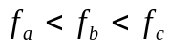
- For good differentiation, the time period T of input signal is
T ≥ R_{F}C_{1.}
APPLICATIONS:
  - In wavaeshaping circuits todetecthigh frequency components in input signal.
  - As Rate of change detector in FM Modualtor.
INPUT AND OUTPUT WAVEFORMS:

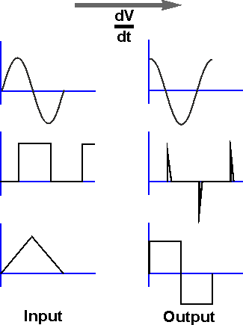

4.Explain the operation of an Integrator circuit (or) Write short notes on

Integrator.(Nov/Dec-18)
- A circuit in which the output voltage wave is the integral of the input voltage waveform is the Integrator or Integration Amplifier.

IDEAL INTEGRATOR
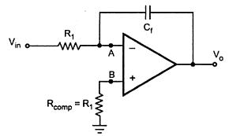
- The nodal equation at node A is,

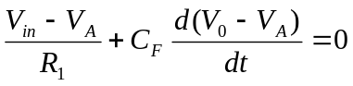

- Since node A is at virtual ground, V_{A}= 0

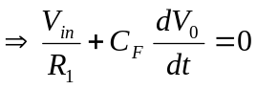

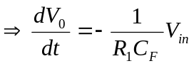

- Integrating on both sides we get,
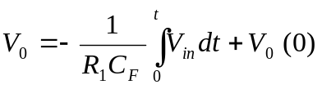

---------------- (1)

Where, V₀(0) is the integration constant indicates the initial output voltage. Thus the output voltage is directly proportional to negative integral of input voltage and inversely proportional to time constant R₁C_{F}.
- In Op-amp integrator the effective input capacitance by Millers theorem is C_{f} (1-A_{v}).
Where, A_{V} → gain of the Op = Amp
- Gain A_{V} is infinite for ideal Op-Amp, so effective time of Op-amp becomes large which results in perfect integration.
- The equation (1) written in phasor notation,
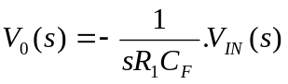
In steady state, s = jω
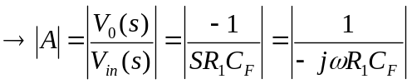

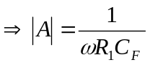
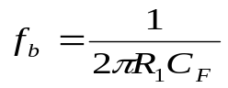
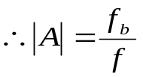 where,
where f_{b} is the frequency where gain is 0dB.

ERRORS IN IDEAL INTEGRATOR:

- At low frequencies (ω≅∼0), the gain becomes infinite (saturates).
- Input offset voltage gets amplified and appears as error voltage which causes saturation.
- It is difficult to pull integrator out of saturation; hence perfect integration is not possible.
- Limited bandwidth.
PRACTICAL OR LOSSY INTEGRATOR:

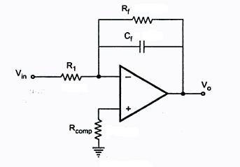

The demerits of ideal circuit are overcome by practical integrator circuit, in which feedback resistor R_{F} is connected across C_{F}. It reduces the low frequency gain of the Op-Amp. It is also called LOSSY INTEGRATOR.
Nodal equation at node X gives,

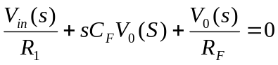
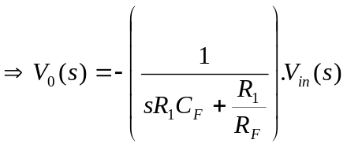
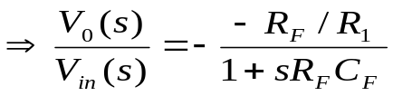

Put s = jω ,
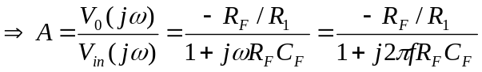
Hence magnitude of the gain of the lossy integrator is given by

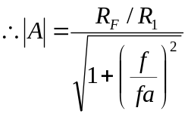
Where,

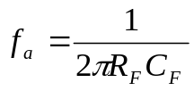, is the break frequency at which gain is (0.707) R_{F} /R₁
- The value of f_{a} is selected such that f_{a}<f_{b}
- f_{b}, the input frequency should be 10 times. f_{a}. i.e f_{b} = 10 f_{a}.

- For perfect integration, time period T of input signal should be, T ≥ R_{F}C_{F.}
APPLICATIONS:

- Analog computers, ADC’s
- Wave shaping circuits.
- Ramp generators.

Input and output waveforms:

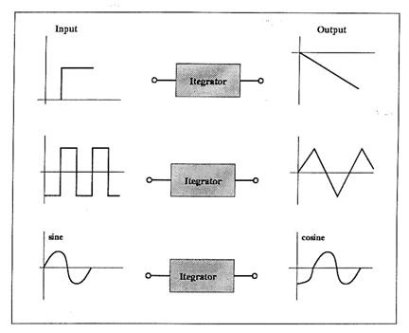

- Explain the operation of an Summer circuit (or) Write short notes on

Summer.(May/June-16)(Nov/Dec-14)
SUMMER

The input impedance of an op-amp is extremely large more than one input signal can be applied to the inverting amplifier circuit gives the addition of the applied signals at the output. Hence it is called summer (or) adder (or summing amplifier).

Depending upon the significance of the output, the summing amplifier circuit classification as,

- Inverting summer (Inverting summing amplifier)

- Non Inverting summer (Non Inverting summing amplifier)

INVERTING ADDER (or) INVERTING SUMMING AMPLIFIER:

- The above circuit is a inverting adder with three input voltages (V₁,V₂ & V₃), three input resistors (R₁, R ₂ & R ₃) and feedback resistor R_{f}.
- Assuming ideal Op-Amp, A_{0L} = ∝ and Ri = ∝
- Since input bias current is zero there is no voltage drop across R_{comp}. Hence the non-inverting terminal is at virtual ground.
- So voltage at node ‘A’ is also zero. Nodal equation by KCL at ‘A’ is

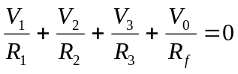 ---------------- (1)
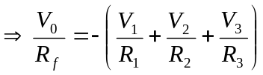
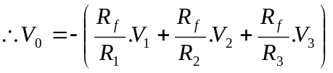 ---------------- (2)
- Thus the output is an inverted, weighted sum of inputs.
- Considering R₁ = R₂ = R₃ = R_{f} in equation (2) we get,
V₀ = - (V₁+ V₂+ V₃) ---------------- (3)
- The output is inverted sum of the inputs. Hence the circuit is called inverting summing amplifier.
- When R₁= R₂ = R₃= 3 R_{f} in (2) we get

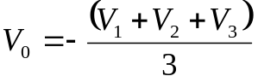

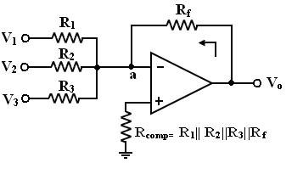

- Thus the output is average of the three inputs. This circuit is called Inverting Averaging Amplifier.

- NON – INVERTING ADDER (or) SUMMING AMPLIFIER:

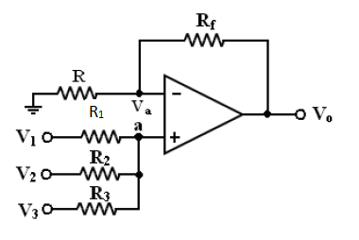
A summer or adder that produces non-inverted sum is called non-inverting summing amplifier. Let the voltage at node at be V_{A}.
  - Hence voltage at inverting terminal is also V_{A}.
  - The nodal equation by KCL at ‘A’ given, as,

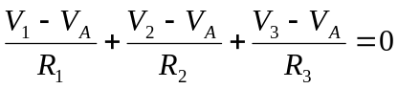
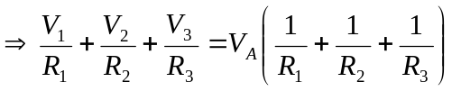

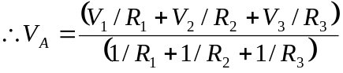 --------------- (1)

  - The Op-amp and two resistors R_{f} and R form a non-inverting amplifier, with
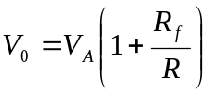 --------------- (2)
  - Substituting equation (1) in (2) we get,

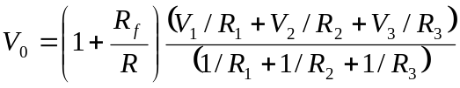 --------------- (3)
which shows output is a non-weighted sum of inputs.

- Let R₁ = R₁ = R₂ = R₃ = R = R_{f} /2 , then equation (A) becomes
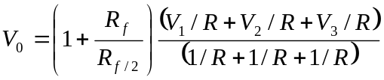
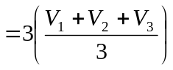
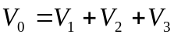

I
6.Explain the operation of voltage to current converter with neat diagram.(April/May-15),(Apr/May-17)

- The voltage to current converter is a circuit the output load current is proportional to the input voltage.

- According to connection of load, there are two types

  - Floating load.

  - Grounded load.

FLOATING LOAD V-I CONVERTER
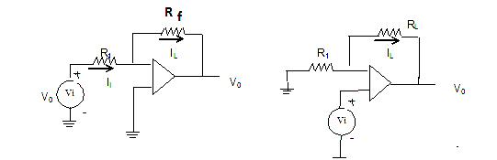

As the input current to an Op-Amp is zero,

I _{L} α V_{i}

Thus the load current is proportional to input voltage and the circuit acts as a voltage to current converter.

If the load is a capacitor, it charges and discharges at a constant rate. Such converters are used to generate Sawtooth or triangular waveforms.

The proportionality constant is generally 1/R_{1.} Hence the circuit is called Transconductance amplifier. It is also called voltage controlled current source. (VCCS).

The load current, I_{L} = V_{i}/R₁ is same for all types of loads. Load can be linear (e.g Resistor), or non-linear (e.g LED) or it can have time dependent.

No matter what the load is, the Op-amp will draw the current I_{i} whose magnitude depends only Vi and R.

GROUNDED LOAD V – I CONVERTER:
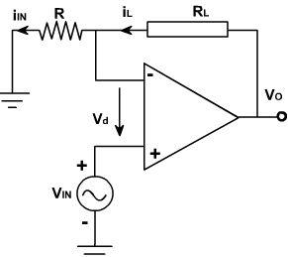

- When one end of the load is grounded, it is called grounded V-I converter. The circuit is also called as how land current converter.

- Write short notes on current to Voltage (I-V) converter. Apr/May -19) I_{i} R
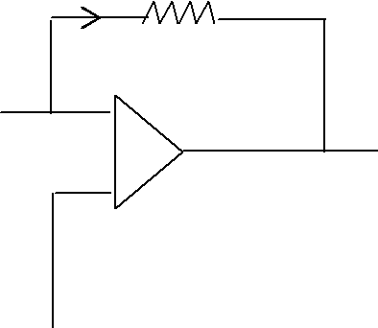

A

V0
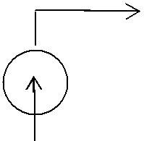

I_{i} B

- The circuit in which the output voltage is proportional to input current is called current to voltage converter. Consider, input current I_{i} and output voltage V₀, then

V ₀ = A.I _{i} | (1)

Where, A Gain of the circuit.
As we measure gain in ohms it is appropriate to denote gain by R.

Hence I-V converter is also called as Transresistance amplifier.

➢ Node B is grounded. Hence node A is at virtual ground.

∴ V _{A} = 0
⇒ _{I} _{i} ₌ ^{V}A ⁻ ^{V}0 ₌ ⁻ ^{V}0

R R

- V ₀ − R .I _{i}

⇒ V ₀ α R . I _{i}

    - Here the output voltage (V₀) is proportional to input current (I_{i}), therefore the circuit is a current to voltage converter.

    - The circuit is also called as current controlled voltage source [CCVS].

    - It the resistance in the circuit is replaced with impedance Z, the circuit is called Trans impedance Amplifier.

- Draw and Explain Inverting Amplifier. (Or) Derive the expression for closed loop gain of an inverting amplifier.(Nov/Dec 2019)

  - An amplifier which provides a phase shift of 180º between input and output is called inverting amplifier.

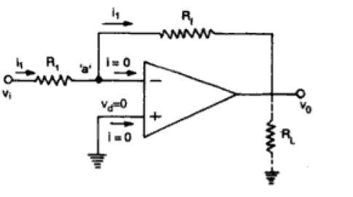

- The output voltage is feedback to inverting input terminal through R_{f}-R₁ network, where R_{f} is the feedback resistor.Input signal (Vi) is applied to the inverting terminal through R₁. The non- inverting terminal is grounded.

ANALYSIS:

At node ‘a’ is at ground potential as Vd = 0, so current I1 through R1 is given as
➢

As input current to op-amp is zero, the same current I1 passes through Rf . So o/p
➢

voltage is I₁ through R₁ is
V ₀ | = − I ₁ . R _{f}
 |  | ⎛ | V_{i} | ⎞
= − |  | ⎜ | V_{i} | ⎟
 |  | ⎜ | ^{R}1 | ⎟^{.R} f |  |  |  | Using equation (1)
 |  | ⎝ | ^{R}1 | ⎠ |  |  |  | Using equation (1)
 |  |  |  | ⎛ | R | f | ⎞
⇒ V₀ |  |  |  | ⎜ |  | f | ⎟
⇒ V₀ | ^{= −V}i ⎜ |  |  |  | ^{R}1 |  | ⎟ | --------------- (2)
 |  |  |  | ⎝ |  |  | ⎠ | --------------- (2)
- Hence closed loop gain of inverting amplifier is

A = | V |  | 0 | = | − R _{f}
CL |  | V_{i} |  |  | R₁ |  | --------------- (A)

Hence negative sign indicates phase shift of 180º.
Effective input impedance is R1.
➢
R1 should be large to avoid loading effect.
➢
Usually load resistor, RL is connected to prevent the reduction in gain.
➢

The load current is given as
➢

I_{L} = V₀ / R_{L}

- If R_{f} >R₁, the gain is greater than 1.

- If R_{f} <R₁, the gain is less than 1.

- If R_{f} = R₁, the gain is unity.
_{f}

- If ^{R}1 = K (Some constant), the circuit is called Scale Changer.

R _{f}

- If ^{R}1 =1, it is called Phase Inverter.

- Bias current compensation is provided with R_{comp} = (R₁|| R_{f}) resistor.

9.Describe Non-inverting amplifier with neat sketch. (or) Derive the Expression for closed loop gain of Non-inverting amplifier.

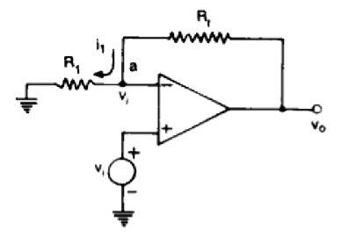

- It the signal is applied to non-inverting terminal and feedback is as shown in circuit, the circuit amplifier without inverting the signal.

- It is a negative feedback system since the output is feedback to inverting terminal.
- Differential input, V_{d} at i/p terminal of op-amp is zero, so at node ‘a’ the voltage is Vi.

- Now R_{f} and R₁ form a potential divider.

Hence,

V0R1
^{V}i ⁼ R₁+ R_{f}

and no current flows into Op-Amp.

V₀ | = | R₁+ R_{f}
V1 | = | R₁+ R_{f}
V1 | = | R₁

A | = | V |  | 0 | = 1 + | R _{f}
CL |  |  | V_{i} |  |  | R₁ |  | --------------- (A)

- The gain can be adjusted to unity or more by proper selection of R_{f} and R₁.

- The input resistance of non-inverting amplifier is extremely large (Ri) as the op-amp draws negligible current from signal source.
- Discuss in detail the DC characteristics of op-amp. (Nov/Dec-14,16,17,19) (Nov/Dec-16)

An ideal op- amp draws no current from the source and its response is also

independent of temperature. However a real op-amp does not work this way. Current is taken from the source into the op=amp inputs. Also the two inputs respond differently to current and voltage due to mismatch in transistor. A real op-amp also shifts its operation with temperature. These non ideal dc characteristics that add error components to the dc output voltage are:

- Input bias current

- Input offset current

- Input offset voltage

- Thermal drift

INPUT BIAS CURRENT

The op-amp input is a differential amplifier, which may be made of BJT (or) FET. In either case, the input transistor must be biased into their linear region by supplying currents into the bases by the external circuits. In an ideal op-amp, we assumed that no current is drawn from the input terminals. However, practically, input terminals do conduct a small value of dc current to bias the input transistor. The bias current entering into the inverting and non-inverting terminals are shown as I_{B}⁻ and I_{B}⁺ in figure (a). Even though both the transistors are identical, I_{B}⁻ and I_{B}⁺ are not exactly equal due to internal imbalances between the two inputs.
Manufactures specify input bias current I_{B}⁺ as the average value of the
base current entering into the terminals of an op-amp.

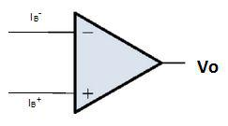

Fig: (a) Input Bias Current

I_{B} = (I_{B}⁺+ I_{B}⁻)/2

Consider the basic inverting amplifier of fig (b). if input voltage Vi is set to zero volt, the output voltage Vo should also be zero volt. Instead, we find the outputvoltage is offset by Vo=(I_{B}⁻) Rf.

This effect can be compensated figure (c) where a compensation resistor Rcomp has been added between the non inverting terminal and ground. Current I_{B}⁺ following through the compensating resistor Rcomp develops a voltage V1 across it. Then,KVL we get –V1 + 0 +V2-Vo=0

Vo=V2-V1

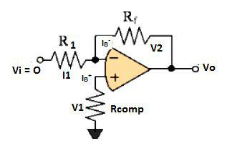

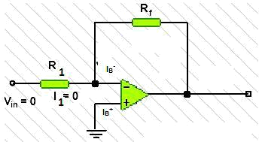
Fig: (c) Bias current compensation in an inverting amplifier

V2 can cancelled V1 and output Vo will be zero.

The value of Rcomp

V1= I_{B}+Rcomp

I_{B}+ = V1/ Rcomp
Vi=0

I1= V1/R1

I2= V2/Rf

Vo =0 ,so Vi=0

V2=V1

I2= V1/Rf

KCL at node a gives, I_{B}- = I2+I1

- V1/Rf+ V1/R1

- V1(R1+Rf)/R1Rf

Assuming

I_{B}⁻ = I_{B}⁺

We get

V1(R1+Rf)/R1Rf = V1/ Rcomp

Rcomp=R1Rf/ R1+Rf

= R1 II Rf

INPUT OFFSET CURRENT (IOS).

Bias current compensation will work if both bias currents I_{B}⁻ and I_{B}⁺ are equal. Since the input transistor cannot be made identical, there will always be small difference between I_{B}⁻ and I_{B}⁺. this is called the offset current.
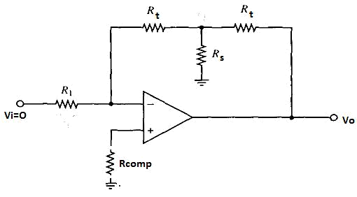

Ios = I_{B}⁺ - I_{B}⁻

The input voltage Vi is zero,

V1= I_{B}+Rcomp

I1= V1/R1

KCL at node a gives I2= I_{B}⁻ - I1

= I_{B}⁻ - (I_{B}⁺ (Rcomp/R1)

Vo=I2Rf-V1

Vo= I2Rf- I_{B}+Rcomp

INPUT OFFSET VOLTAGE (Vios)

The output voltage may still not be zero with zero input voltage. This is due to
unavoidable imbalences inside the opamp and zero have to apply a small
voltage at the input terminal to make output voltage zero.
This voltage is called input offset voltage.

The voltage V2 at negative input terminal given by V2=(R1/(R1+Rf))Vo

Vo= ((R1+Rf)/R1)V2

= (1+(Rf/R1))V2

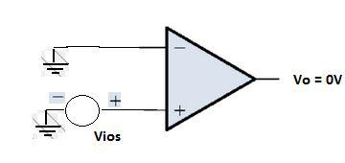
Vios= IVi-V2I and Vi = 0

Fig: op-amp showing input offset voltage

THERMAL DRIFT

In an op-amp the bias current, offset current and off set voltage changes with change in temperature. Offset current drift is measured in nA/ ⁰C and offset voltage drift is measured in mV/ ⁰C. These indicate the change in offset current or voltage for each degree Celsius change in temperature. Forced air cooling may be used to stabilize the ambient temperature.

11.Explain the operation of a basic differential amplifier?(Nov/dec 2017)

The transistorized differential amplifier basically uses the emitter based circuits which are identical in characteristics.
The two collector resistances are equal i.e., R_{C1}=R_{C2}=R_{C ,} also emitter resistances arec equal i.e., R_{E1}=R_{E2}=R_{E.} The magnitudes of +V_{CC} and –V_{EE} are also same. The inputs V_{S1} and V_{S2} are given to the bases B₁ and B₂ of transistor Q₁ and Q₂ respectively.
The balanced output is taken across the colletors’ C₁ and C₂. Such an amplifier is called emitter coupled differential amplifier. The modes of operation are as follows.

DIFFERENTIAL MODE OPERATION:

In Differential mode operation, the two input signals are equal in magnitude but 180 ⁰ out of phase.
These signals are obtained from centre tap transformers. Since wave at base of Q₁ is assumed as positive at base of Q₂ is assumed as negative.

Due to positive going signal on Q₁ , amplified –Ve going signal is developed on collector of Q₁ and positive going signal is developed across R_{E.}
similarly due to negative going signal on Q₂ , amplified +Ve going signal is developed on collector of Q₂ and negative going signal is developed across R_{E}. These two signals cancel each other and there is no signal across emitter resistance.

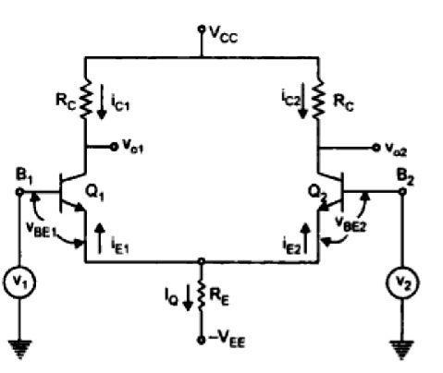
Hence there is no a.c signal current flowing through R_{E}. So it is doesn’t introduce –Ve feed back. The output V₀ is taken across collector of Q₁ and Q₂. The outputs across the collectors will equal in magnitude but of opposite polarity. So V₀ is the difference between these two signals e.g +10-(-10) = +20V. Hence the difference output V₀ is twice as large as signal voltage.

COMMON MODE OPERATION:

 | +V_{CC}
R_{C} | R_{C}
 | V_{O} ≈ 0
^{R}S1 | ^{R}S2
Q₁ | Q₂
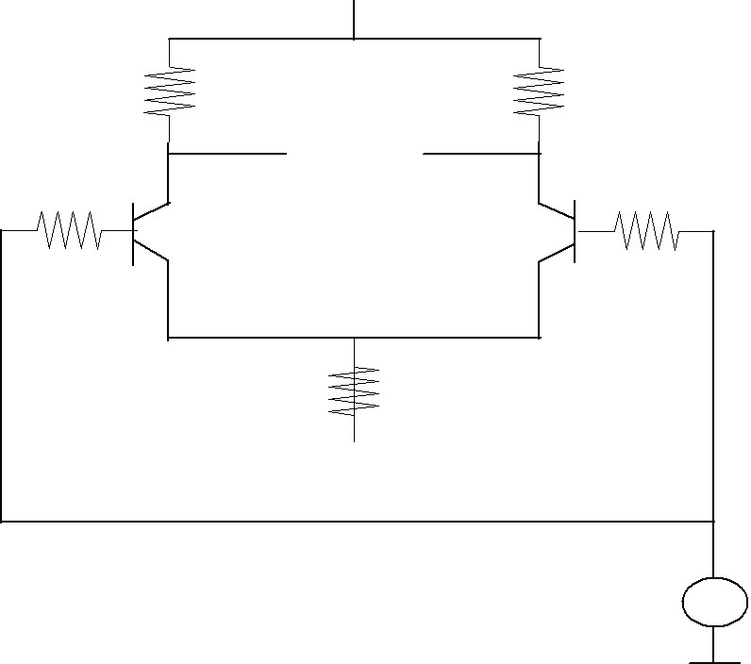

- Explain in detail the d.c analysis of a basic differential amplifier or obtain the expression for operating point values of a basic differential amplifier. (April/May 16)

 | +V_{CC}
^{R}C | ^{R}C
I_{C} | I_{C}
^{R}S1 | ^{R}S2 | ^{V}S2 | = 0
V_{S1} = 0 | Q₂ | ^{V}S2 | = 0
Q₁ | Q₂
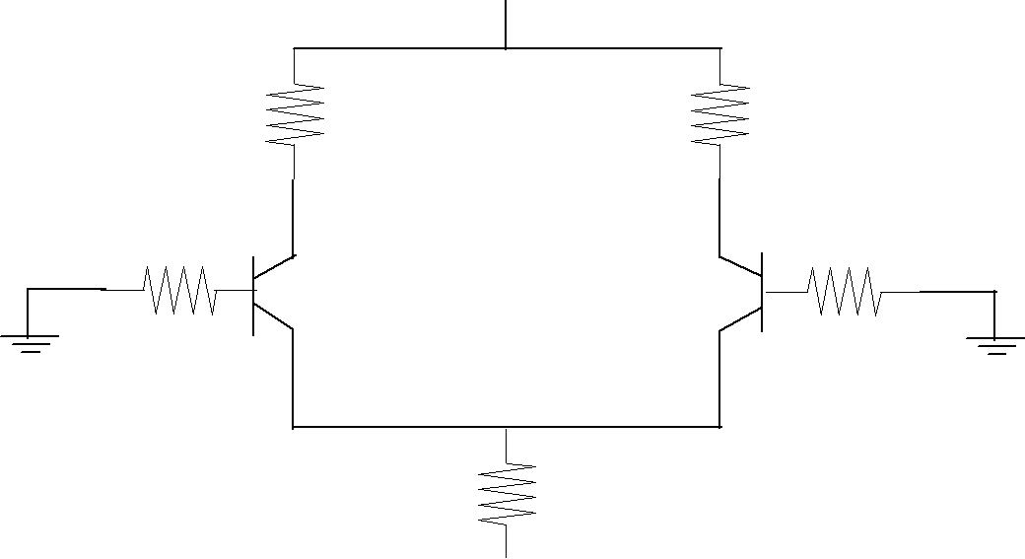

^{R}E
-V_{EE}

D.C analysis obtaining the operating point values (I_{CQ} and V_{CEQ}) for the transistors used.

The d.c equivalent circuit is obtained by reducing the a.c signals to zero. Assume R_{S1} = R_{S2} = R_{S.} The transistors Q₁ and Q₂ are matched transistors, hence

- Both Q₁ and Q₂ have same characteristics

- R_{E1} = R_{E2} hence, R_{E} = R_{E1}|| R_{E2}

- R_{C1} = R_{C2} = R_{C}
- |V_{CC}| = |V_{EE}| and both are measured with respect to ground Applying KVL to base emitter loop of Q_{1,}

From the above equation we observe,

- R_{E} determines the value of emitter current of Q₁ and Q₂ for known values of V_{EE .}

- The emitter current through Q₁ and Q₂ is independent of collector resistance R_{C.} Collector voltage of Q₁ is given as

V_{C} = V_{CC} – I_{C} R_{C}

Neglecting the drop across R_{S,} voltage at emitter of Q₁ is approximately –V_{BE.} Hence V_{CE is} given as

 | V_{CE} = V_{C} -V_{E} = ( V_{CC}– I_{C} R_{C} ) – (–V_{BE})
 |  |  | (B)
 | V_{CE} = V_{CC} + V_{BE} – I_{C} R_{C} | ---------------------- | (B)
Hence | I_{E} = I_{C} = I_{CQ}
And | VCE = VCEQ
For given values of | V_{CE} and V_{EE.} Since both Q₁ and Q₂ are identical, operating

points are also same for both the transistors.

- Explain in detail the a.c analysis of dual input, balanced output differential

amplifier or derive the expression for differential gain, common mode gain, CMRR, R_{I} and R_{O} of an emitter coupled differential amplifier.

The a.c analysis is done by using h- parameters

1. DIFFERENTIAL GAIN (A _{d}):

+V_{CC}
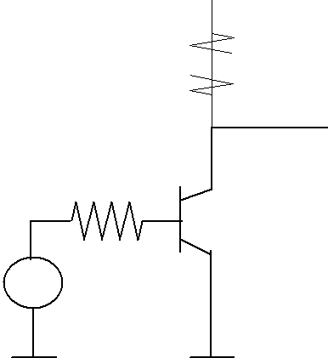

R_{C} 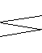

^{V}o
R_{S}

^{Q}1
^{I}b
V_{S} / 2

Fig: a.c Equivalent circuit for differential mode operation

The differential gain is obtained b taking V_{S1} = V_{S2} = V_{S} / 2. The two emitter currents I_{C1,} I_{C2} are equal in magnitude and 180⁰ out of phase. Hence they cancel each other to get resultant a.c current through emitter s zero. Thus for a.c purposes emitter terminal is grounded.Since both the transistors are matched, the a.c equivalent circuit for the other transistor is identical to the one shown in figure. This is called half circuit concept of analysis. This the differential gain of dual input, balanced output differential amplifier.

- COMMON MODE GAIN (A_{C}):

Let the magnitude of both a.c input signals be V_{S} and are in phase with each other. Hence differential input V_{d} is zero and common mode input V_{C} is average of the 2 inputs.

We know that common mode gain A_{C} is given by,

 | R_{S} | B |  |  |  | C
 |  | B |  |  |  | C | - | V_{o}
+ | I_{b} | + | ^{h}fe^{I}b |  |  | + | - | V_{o}
+ | I_{b} | h | ^{h}fe^{I}b |  |  | h |  | R
 |  | h |  |  |  | h |  | C
^{V}S |  | ie | I_{L} |  | I_{B} | oe
^{V}S |  | - | I_{L} | E | I_{B} | - | +
- |  |  |  |  |  |  |  | ^{I}L
 |  |  | 2R_{E}
 |  |  |  |  | (I_{L}+I_{B})
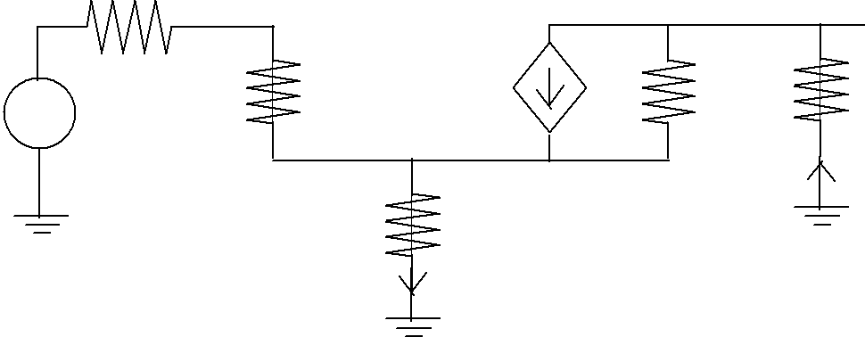

Fig: Approximate hybrid model

Since emitter currents I_{e1} = I_{e2} = I_{e,} flows through R_{E} in same direction, total current through R_{E} is 2I_{e.} So for simplicity emitter resistance is assumed as 2R_{E} and emitter current is assumed as I_{e .} So,

➢ Current through R_{C} = load current I_{L}

➢ Effective emitter resistance = R_{E}

➢ Current through emitter resistance = I_{L} + I➢ Current through h_{oe}= (I_{L} – h_{fe.}I_{b)}
CMRR:

The expression for common mode gain is given as

CMRR = |  | A_{d}
CMRR = |  | A_{c}

= | ^{h} fe ^{.R}C | * | 2 R_{E} (1 + h _{fe} ) + R_{S} + h_{ie}
= | R_{S} + h_{ie} | * | ^{h} fe ^{.R}C

_{CMRR} ₌ ^{R}S ⁺ ^{h}ie ⁺ ^{2R}E ⁽¹ ⁺ ^{h} fe ⁾
R_{S} + h_{ie} | --------------------- (C)

This is CMRR for dual input balanced output differential amplifier.

- DIFFERENTIAL INPUT RESISTANCE (R_{T}):

R_{i} is the equivalent resistance between one of the input and the ground when the other input terminal is grounded. Hence

R_{i} | = | V_{S}
R_{i} | = | I _{b} | ---------------------- (9)

We know from analysis in differential mode

 | I _{b} = | V_{S}
 | I _{b} = | 2( R_{S} |  | + h_{ie} ) | --------------------- (10)
Substitute (10) in (9), we get
 |  |  |  |  | (D)
 | R_{i} = 2(R_{S} + h_{ie} |  | ) |  | (D)

R_{i} is same for both balanced and unbalanced output.

- OUTPUT IMPEDANCE (R₀):

It is defined as equivalent resistance between one of the output terminals with respect to ground. From the hybrid model of common mode operation, we see that output resistance between output terminals and ground is R_{C}.

13.Discuss in detail about the frequency response of Op-amp.(Nov/Dec 19)

The a.c characteristics of an op-amp includes frequency response, Slew rate etc. An ideal Op-Amp has infinite bandwidth, but practical Op-Amp gain decreases at higher frequencies. This process is called roll-off and the rate at which the gain decreases is called roll-off rate.
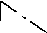

v₁ |  | ^{R}O |  | v_{o}
v_{d} | R | A | V | C
 | i | OL | d
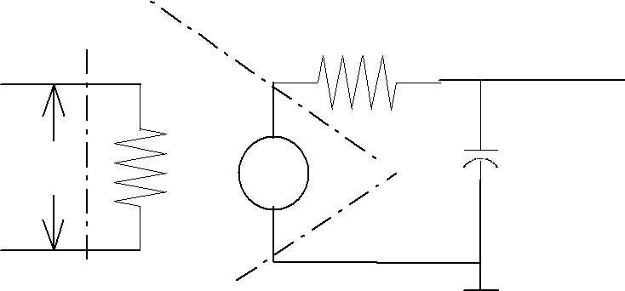
v₂
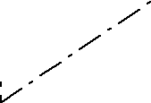

For an Op-Amp with single break (corner) frequency all capacitive effects can be represented by a single capacitor C. The high frequency model shown above is the modified version of low frequency model with a capacitor C at the output. There is only one pole due to R_{o}C and one -20dB/decade roll off rate comes into effect. The open loop gain of an op-amp with one corner frequency is derived as follows the corner frequency or upper 3-dB frequency.
- for frequency f << f1, the magnitude of the gain is 20 log (A_{OL}) in dB.

- At frequency, f=f1, the gain is 3 dB down the D.C value of A_{OL} in dB. This frequency (f₁) is called corner frequency.

- For f >> f_{1,} the gain rolls-off at the rate of -20 dB/decade or -6 dB/octave. From phase plot, we see

For f = 0, the phase angle is zero. At f = f_{1,} the phase angle Ф = - 45°
At infinite frequency, the phase angle, Ф becomes - 90° The voltage transfer function in s-domain is given by,

put s = j ω, in the above equation,

Considering a practical op-amp with three break frequencies the transfer function is given as,Where ω_{o} < ω₁ < ω₂ < ω₃.

 | MAGNITUDE PLOT |  |  | PHASE PLOT
20 log (A_{OL}) dB |  |  |  |  | Phase,
 |  |  |  |  | Ф
 |  | 3 dB |  |  | 0
 |  |  |  |  | °
 |  |  |  |  | -
 |  |  |  |  | 45°
 | f1 |  |  | - |  | f1 | f
 | f1 |  | f | 90° |  | f1 | f
 |  |  | (Hz) |  |  |  | (Hz)
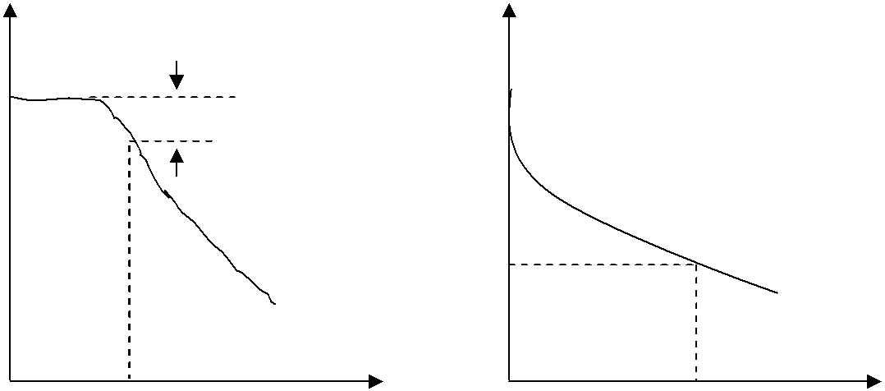

A_{O L} (dB)
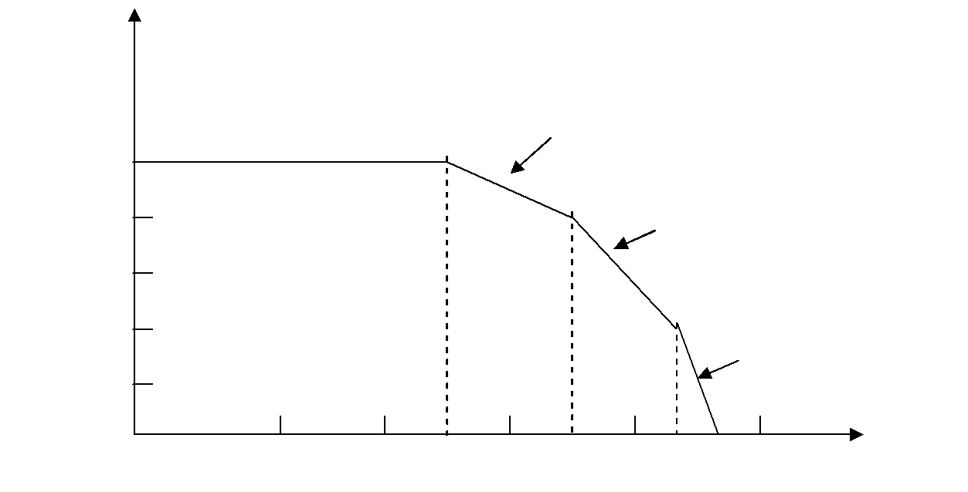

-20dB/decade

100

80 -40dB/decade

60

40
-60dB/decade

20

1k 10k 100k f₁ 1M f₂ _{f3} ¹⁰⁰ _{f (on log scale)}

